Example No 01: Make a calculator to calculate the Area in feet and inches.

Input:

using System;

namespace Home_task_01

{

class Program

{

static void Main(string[] args)

{

//Make a calculator to calculate area in feet and inches

//We have:

// Length = 15 feet, 6 inches

// Breadth = 16 feet, 5 inches

// Formula:

// Area = Length * Breadth

// Where;

// li = Length in inches

// lf = Length in Feet

// bi = Breadth in inches

// bf = Breadth in Feet

// ai = Area in Inches

// af = Area in Feet

int li, lf, bi, bf, ai, af;

li = 6;

lf = 15;

bi = 5;

bf = 16;

ai = li * bi;

af = lf * bf;

if (ai >= 12) { int r = ai / 12;

af = af + r;

int i = ai % 12;

ai = i;

}

Console.WriteLine("The Area is {0} feets and {1} inches", af, ai);

}

}

}

Output:

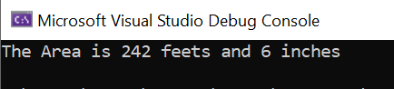

Example No 02: Make an Interest Calculator.

Input:

using System;

namespace Home_Task_02

{

class Program

{

static void Main(string[] args)

{

//Calculate the value of interest by taking principle value from user.

//We have:

// i = interest

// p = Principle value

// r = Rate

// t = Time

//Formula:

// i = (p*t*r)/100

double p, t;

double r, i;

Console.WriteLine("Please enter the Principal amount:");

p = Convert.ToDouble(Console.ReadLine());

Console.WriteLine("For How many years?");

t = Convert.ToDouble(Console.ReadLine());

r = 16.5;

i = p * t * r / 100;

double finalAmount = i + p;

Console.WriteLine("Your ammount after {0} Years will be {1} Rupees.", t, finalAmount);

}

}

}

Output:

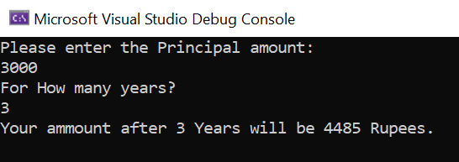

Example No 03: Make a temperature converter that convert Kelvin in Fahrenheit.

Input:

using System;

namespace Home_Task_03

{

class Program

{

static void Main(string[] args)

{

//Convert temperature from Kelvin To Fahrenheit

//We have:

// k = temperature in kelvin

// f = temperature in fahrenheit

// c = temperature in celcius

//Formula:

// f = 9 / 5 * (k - 273) + 32;

// where c = k - 32;

Double k, f, c;

Console.WriteLine("Enter Temperature in Kelvin:");

k = Convert.ToDouble(Console.ReadLine());

c = k - 273;

f = 9/5 * c + 32;

Console.WriteLine("The Temperature in Fahrenheit is=" + f);

}

}

}

Output:

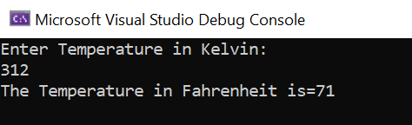

Home Task 01: Calculate distance covered by a body moving with uniform velocity.

Input:

using System;

namespace Home_Task_04

{

class Program

{

static void Main(string[] args)

{

//Calculate the distance covered by a body moving with uniform velocity.

// we have:

// s = Distance

// v = Uniform Velocity

// t = Time

//Formula:

// s = v*t

Double s, v, t;

Console.WriteLine("Enter The Velocity of Vehicle (m/s):");

v = Convert.ToDouble(Console.ReadLine());

Console.WriteLine("Enter the time in seconds:");

t = Convert.ToDouble(Console.ReadLine());

s = v * t;

Console.Write("The Distance Covered by Vehicle is "+s);

Console.Write(" m");

}

}

}

Output;

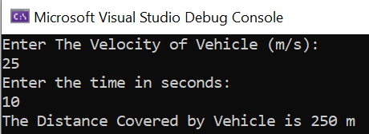

Home Task 02: Calculate the final velocity of a Vehicle by using 1st Equation of Motion.

Input:

using System;

namespace Home_Task_05

{

class Program

{

static void Main(string[] args)

{

Double vf, vi, a, t;

Console.WriteLine("Enter initial Velocity: ");

vi = Convert.ToDouble(Console.ReadLine());

Console.WriteLine("Enter the acceleration: ");

a = Convert.ToDouble(Console.ReadLine());

Console.WriteLine("Enter time in seconds: ");

t = Convert.ToDouble(Console.ReadLine());

vf = vi + a * t;

Console.WriteLine("The final velocity of vehicle after {0} second is {1} m/s", t, vf);

}

}

}

Output:

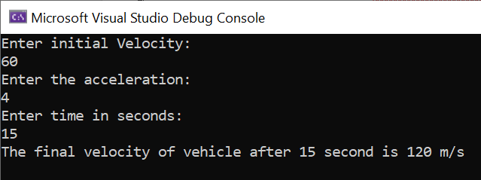

Home Task 03: Calculate distance By using second Equation of motion.

Input:

using System;

namespace Home_Task_05

{

class Program

{

static void Main(string[] args)

{

Double vi, t, a, s;

Console.WriteLine("Enter initial velocity: ");

vi = Convert.ToDouble(Console.ReadLine());

Console.WriteLine("Enter time in seconds: ");

t = Convert.ToDouble(Console.ReadLine());

Console.WriteLine("Enter acceleration: ");

a = Convert.ToDouble(Console.ReadLine());

s = vi * t + 1/2*(a * t * t);

Console.WriteLine("The distamce covered by Vehicle is: " + s);

}

}

}

Output:

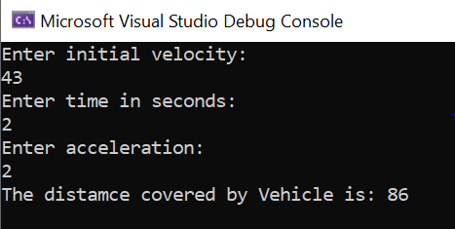

Home Task 04:

Input:

using System;

namespace Home_Task_05

{

class Program

{

static void Main(string[] args)

{

double a, s, vf, vi;

// Console.WriteLine("enter the acceleration");

//a = Convert.ToDouble(Console.ReadLine());

Console.WriteLine("enter the final velocity");

vf = Convert.ToDouble(Console.ReadLine());

Console.WriteLine("enter the initial velocity");

vi = Convert.ToDouble(Console.ReadLine());

Console.WriteLine("enter the Distance: ");

s = Convert.ToDouble(Console.ReadLine());

a = (vf * vf - vi * vi)/2*s;

Console.WriteLine("tHE REQUIRED ACCELERATION IS"+a);

}

}

Output:

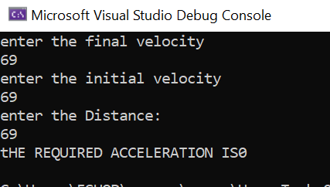

**Home Task 05:** Make a program to identify whether the number is Even or Odd.

**Input:**

using System;

namespace Home_Task_08

{

class Program

{

static void Main(string[] args)

{

Console.WriteLine("Enter Number");

int num1 = Convert.ToInt32(Console.ReadLine());

if (num1 % 2 == 0)

{ Console.WriteLine("{0} is Even", num1); }

else { Console.Write("{0} is Odd", num1); }

}

}

}

**Output:**

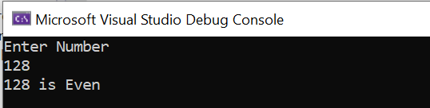

**Home Task 06:** Make a Program to identify which subject have Highest marks in given subjects.

**Input:**

using System;

namespace Home_Task_09

{

class Program

{

static void Main(string[] args)

{

//m = Maths

//p = Physics

//c = Chemistry

int m, p, c;

Console.WriteLine("Enter marks in Maths");

m = Convert.ToInt32(Console.ReadLine());

Console.WriteLine("Enter marks in Physics");

p = Convert.ToInt32(Console.ReadLine());

Console.WriteLine("Enter marks in Chemisrty");

c = Convert.ToInt32(Console.ReadLine());

if (m>p)

{ if (m>c)

{ Console.WriteLine("Maths marks are Max"); }

else

{ Console.WriteLine("Chemistry marks are Max"); }

}

else if (c>p)

{ Console.WriteLine("Chemistry marks are Max"); }

else

{ Console.WriteLine("Physics marks are Max"); }

}

}

}

**Output:**

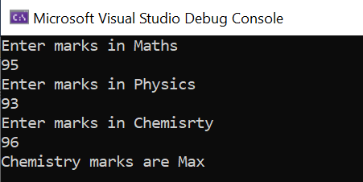

Home task 07: Make a program to identify which side of triangle is Hypotenuse.

Input:

using System;

namespace Home_Task_11

{

class Program

{

static void Main(string[] args)

{

int a, b, c;

Console.WriteLine("Enter length of side 1");

a = Convert.ToInt32(Console.ReadLine());

Console.WriteLine("Enter length of side 2");

b = Convert.ToInt32(Console.ReadLine());

Console.WriteLine("Enter length of side 3");

c = Convert.ToInt32(Console.ReadLine());

if(a>b)

{ if(a>c)

{ Console.WriteLine("Side 1 is the Hypotanuse"); }

else

{ Console.WriteLine("Side 3 is the Hypotanuse"); }

}

else if (c>b)

{ Console.WriteLine("Side 3 is the Hypotanuse"); }

else

{ Console.WriteLine("Side 2 is the Hypotanuse"); }

}

}

}

Output:

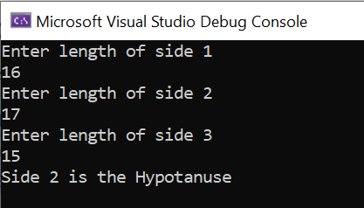

Home Task 08: Make a program To Calculate Total Expenditure of a Year

1. Implementation of Program By using For Loop

using System;

namespace Abdullah_Sadiq_CP_Home_Tasks

{

class Program

{

static void Main(string[] args)

{

//tot_exp = total expenditure

int tot_exp = 0;

int exp;

for ( int m = 1; m <=12; m++)

{

Console.WriteLine("Enter Expenditure of Month {0}:", m);

exp = Convert.ToInt32(Console.ReadLine());

tot_exp += exp;

}

Console.WriteLine("Total Expenditure = {0}", tot_exp);

}

}

}

1. Implementation of Program By Using While Loop

using System;

namespace Abdullah_Sadiq_CP_Home_Tasks

{

class Program

{

static void Main(string[] args)

{

int tot_exp = 0;

int exp;

int m = 1;

while (m <=12)

{

Console.WriteLine("Enter Expenditure for Month {0}:", m);

exp = Convert.ToInt32(Console.ReadLine());

tot_exp += exp;

m++;

}

Console.WriteLine("Total Expenditure = {0}", tot_exp);

}

}

}

1. Implementation of Program By using Do While.

Input:

using System;

namespace Abdullah_Sadiq_CP_Home_Tasks

{

class Program

{

static void Main(string[] args)

{

int exp, tot_exp = 0, m = 1;

do

{

Console.WriteLine("Please Enter Expenditure for Month {0}:", m);

exp = Convert.ToInt32(Console.ReadLine());

tot_exp += exp;

m++;

}

while (m <= 12);

Console.WriteLine("Total Expenditure = {0}", tot_exp);

}

}

}

Output:

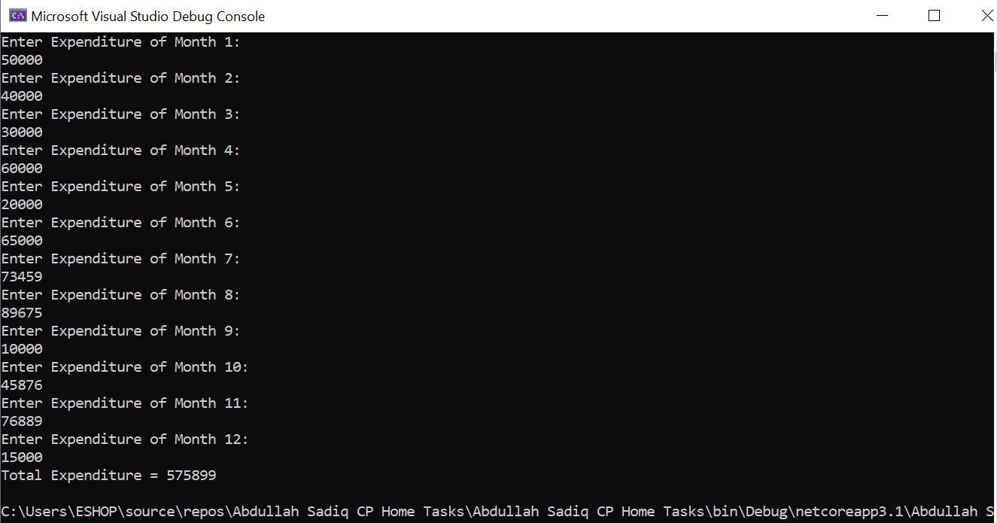

Task No 09: Make a program to maintain a List of people aged above 20.

Input:

using System;

namespace Abdullah_Sadiq_CP_Home_Tasks

{

class Program

{

static void Main(string[] args)

{

int age, n = 0;

char rep;

do

{

Console.WriteLine("Enter your Age:");

age = Convert.ToInt32(Console.ReadLine());

if (age > 20)

{

n++;

}

Console.WriteLine("Is he the Last Student? (press 'y' for Yes, 'n' for No)");

rep = Convert.ToChar(Console.ReadLine());

}

while (rep == 'n' || rep == 'N');

Console.Write("The No of student above Age 20 is = ");

Console.WriteLine(n);

}

}

}

Output:

Task No 09: Make a program to count no of Odd and Even Number accepted.

Input:

using System;

namespace Abdullah_Sadiq_CP_Home_Tasks

{

class Program

{

static void Main(string[] args)

{

//e = even

//o = odd

int e = 0, o = 0, num;

for (int cnt = 0; cnt < 5; cnt++)

{

Console.WriteLine("Enter a Number:");

num = Convert.ToInt32(Console.ReadLine());

if (num % 2 ==0)

{

e++;

}

else

{

o++;

}

}

Console.WriteLine("The total Odd Numbers are {0}", o);

Console.WriteLine("The total Even Numbers are {0}", e);

}

}

}

Output:

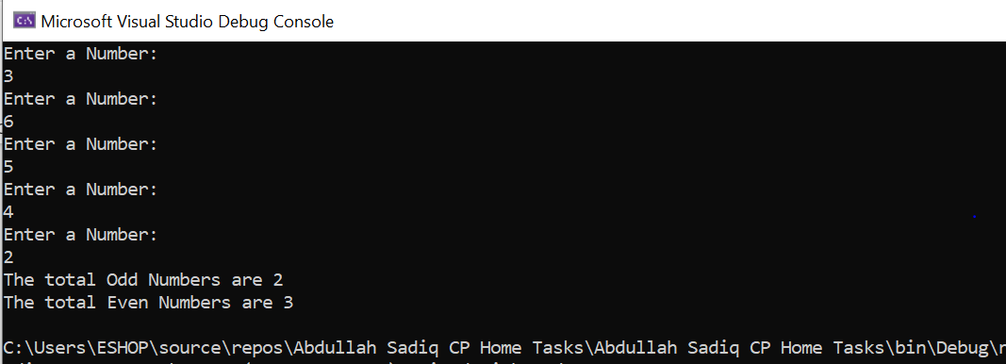

Task No 10:

Input:

using System;

namespace Abdullah_Sadiq_CP_Home_Tasks

{

class Program

{

static void Main(string[] args)

{

double bill, dis, payment;

Console.WriteLine("Enter Billing Amount (in Rs):");

bill = Convert.ToDouble(Console.ReadLine());

if (bill >100)

{

dis = bill * 0.1;

}

else

{

dis = 0;

}

payment = bill - dis;

Console.WriteLine("The Ammount to pay is {0} With discount of {1} Rs", payment, dis);

}

}

}

Output:

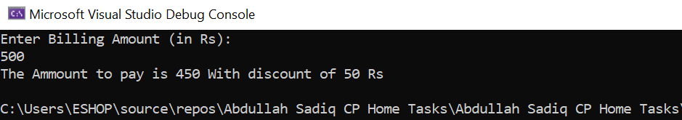

Task No 11: Make a Program to Check whether the citizen is Valid for voting or not.

Input:

using System;

namespace Abdullah_Sadiq_CP_Home_Tasks

{

class Program

{

static void Main(string[] args)

{

string nationality, nic;

int age;

Console.WriteLine("Verify! Are You Eligible For Voting?");

Console.WriteLine("\nPlease Enter your Nationality (Press 'P' for Pakistani, 'O' for Other):");

nationality = Console.ReadLine();

if (nationality.Equals ("P") || nationality.Equals("p"))

{

Console.WriteLine("Enter your Age:");

age = Convert.ToInt32(Console.ReadLine());

if (age >=18)

{

Console.WriteLine("Are you NIC Holder? (Press 'Y' for Yes, 'N' for No):");

nic = Console.ReadLine();

if (nic.Equals ("Y") || nic.Equals("y"))

{

Console.WriteLine("You are a Valid Voter.");

}

else

{

Console.WriteLine("Please Apply for Nic First !");

}

}

else

{

Console.WriteLine("You are not Eligible Since you are Under 18!");

}

}

else

{

Console.WriteLine("Sorry! This Facility is Only available for Pakistani Citezens.");

}

}

}

}

Output:

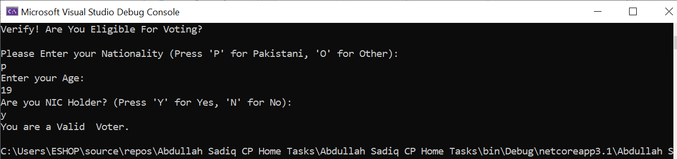

Task No 12:

Input:

Output:

Task No 13:

Input:

Output:

Task No 14:

Input:

Output:

Task No 15:

Input:

Output:

Task No 16:

Input:

Output:

Task No 17:

Input:

Output: